AGRICULTURAL ECONOMICS
Comprehensive Study Notes

📚 This document contains 11 comprehensive chapters covering all core topics of Agricultural Economics, complete with diagrams, detailed explanations, comparison tables, memory tips, and a full Quick Revision section. All graphs from the original PDF have been retained.

TABLE OF CONTENTS

1. Introduction to Agricultural Economics ......................
1.1 Definitions of Economics
1.2 Branches of Economics (Micro & Macro)
1.3 Classification of Goods
1.4 Utility and Its Types
1.5 Consumer Behaviour
2. Law of Demand .......................................................................
2.1 Demand Curves & Shifts
2.2 Kinds of Demand
2.3 Giffen Goods
2.4 Elasticity of Demand & Diagrams
2.5 Determinants of Price Elasticity
2.6 Supply Curves & Market Equilibrium
3. Cost Concepts ...........................................................................
3.1 Short Run vs Long Run
3.2 Fixed Cost, Variable Cost & Diagrams
3.3 Total Cost, AVC, AFC, ATC, MC (with Graphs)
3.4 Combined Cost Curve Analysis
4. Rural Credit and Agriculture Finance ............................
4.1 Classification of Credit
4.2 Cooperative Movement in India
5. Important Banking & Finance Institutions ..................
5.1 Reserve Bank of India (RBI)
5.2 Regional Rural Banks (RRBs)
5.3 NABARD
6. International Organizations & Institutions .................
6.1 IMF, World Bank, WTO, ADB, FAO, EXIM Bank
7. Agricultural Marketing ...........................................................
7.1 Utility Added by Marketing
7.2 Market Structures Comparison Table
7.3 Classification of Agricultural Markets
7.4 Marketing Channels
7.5 Producers Surplus & Marketing Costs
8. Farm Management .....................................................................
8.1 Objectives & Principles
8.2 Production Factors (Land, Labour, Capital, Org.)
8.3 Economic Laws in Farm Management
8.4 Types & Systems of Farming
9. Depreciation ................................................................................
10. Farm Planning & Budgeting ..................................................
11. Important Facts & Quick Revision .....................................

Chapter 1 — Introduction to Agricultural Economics
📖 Agricultural Economics
"A science which deals with the principles and methods of economics applied to the special conditions of the agricultural industry."
— Standard Definition

➤ Origin: The word "Economics" is derived from the Greek word Oikonomia (household management).
➤ Founding Father: Father of Economics: Adam Smith (Book: "Wealth of Nations", 1776).
➤ Indian Context: Chanakya described economics as Arthashastra — the science of material gain.
1.1 Four Important Definitions of Economics
Wealth Definition  — Adam Smith (1776) | "An enquiry into the nature and causes of the wealth of nations."  💡 Economics is the study of wealth creation and its distribution.

Welfare Definition  — Alfred Marshall (1890) | "Study of mankind in the ordinary business of life — examines the part of individual and social action most closely connected with the attainment and use of the material requisite of well-being."  💡 Economics is about human welfare, not just wealth.

Scarcity Definition  — Lionel Robbins (1932) | "Science which studies human behaviour as a relationship between ends and scarce means which have alternative uses."  💡 Scarcity + Choice = Economics.

Growth Definition  — J. M. Keynes (Father of Modern Economics) | "Study of the administration of scarce resources and of the determinants of employment and income."  💡 Focuses on macroeconomic variables like employment, income, and output.

1.2 Contribution of Scientists
🎓 Adam Smith [Father of Economics.] Book: "Wealth of Nations". Introduced Wealth Definition.
🎓 Alfred Marshall [Father of Microeconomics.] Concepts of Diminishing Marginal Utility, Equimarginal Utility, Consumer Surplus.
🎓 J. M. Keynes [Father of Modern Economics.] Book: "General Theory of Employment, Interest and Money". Growth Definition of Economics.
🎓 Ragnar Frisch [Norwegian Economist.] Coined the terms Microeconomics and Macroeconomics.
🎓 Chanakya [Ancient Indian Scholar.] Described economics as Arthashastra — science of material gain and statecraft.
1.3 Branches of Economics
Economics is divided into two main branches:
Microeconomics | Macroeconomics
Studies individual economic units | Studies the economy as a whole
Consumer behaviour, firm pricing | National income, employment, inflation
Deals with individual demand/supply | Deals with aggregate demand/supply
Price determination of specific goods | Monetary and fiscal policies
Example: Pricing of wheat | Example: National agricultural GDP

1.4 Classification of Goods
Goods are classified on multiple bases:
Basis | Type | Sub-type | Example
Transferability | External-Material | Transferable | Land, Building
 |  | Non-transferable | Degree certificate
 | External-Personal | Transferable | Goodwill of business
 |  | Non-transferable | Friendship, courage
 | Internal | Non-transferable | Personal qualities
Supply | Free Goods | Value in use only | Air, Sunlight
 | Economic Goods | Value in use + exchange | Wheat, Tractor
Durability | Mono-period | Used only once | Food items
 | Poly-period | Used multiple times | Tractor, pump
Consumption | Consumer (1st order) | Yield satisfaction directly | Food, clothing
 | Producer (2nd order) | Help produce other goods | Fertiliser, seeds

1.5 Utility and Its Types
📖 Utility
"The want-satisfying power of a good. It is subjective, relative, and has no ethical or moral significance. Measured in units called "Utils"."

Marketing adds cost to the product but simultaneously creates four types of utility:
📦 Form Utility: Created by processing/changing the form of a good. (e.g., Converting raw wheat into flour.)
🚛 Place Utility: Created by transporting goods from surplus to deficiency areas. (e.g., Transporting apples from J&K to Delhi.)
🕐 Time Utility: Created by storing goods and making them available at the right time. (e.g., Storing wheat after harvest for off-season use.)
🤝 Possession Utility: Created by transfer of ownership from seller to buyer. (e.g., Buying a bag of fertiliser from a shop.)
📌 REMEMBER: Law of Diminishing Marginal Utility: As a consumer consumes successive units of a good, the marginal utility of each additional unit decreases. When Total Utility is MAXIMUM, Marginal Utility is ZERO.

1.6 Consumer Behaviour — Want, Desire, Demand
Stage | Definition | Example | Key Condition
WANT | Wishful thinking without ability to fulfil | Wishing to own a Range Rover | No ability or action
DESIRE | Ability to fulfil the want exists | Having money to buy a purse | Ability present, no action
DEMAND | Want fulfilled at specific place and time | Actually buying the purse | Ability + Action + Specific time/place

Chapter 2 — Law of Demand
📖 Law of Demand
"When the price of a commodity increases, the quantity demanded decreases, and vice versa — all other factors remaining constant (ceteris paribus)."
— Classical Economics

2.1 The Demand Curve
The demand curve slopes downward from left to right, showing the inverse (negative) relationship between price and quantity demanded.
➤ Fall in price → Expansion in demand (downward movement along the same curve).
➤ Rise in price → Contraction in demand (upward movement along the same curve).
➤ These are MOVEMENTS along the curve — not shifts.
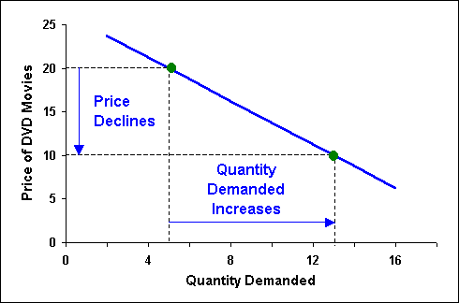
Figure: Law of Demand — Downward sloping demand curve (Price falls → Quantity demanded rises)
2.2 Increase and Decrease in Demand (Shifts)
A shift in the demand curve occurs when factors OTHER THAN PRICE change:
Factors Causing Demand Shift | Direction of Shift
Increase in consumer income (normal goods) | Rightward (Increase in demand)
Decrease in consumer income | Leftward (Decrease in demand)
Rise in price of substitute goods | Rightward (demand for this good rises)
Fall in price of substitute goods | Leftward
Favourable change in taste/fashion/preference | Rightward
Unfavourable change in taste/fashion | Leftward
Peak season (e.g., fans in summer) | Rightward
Off season | Leftward

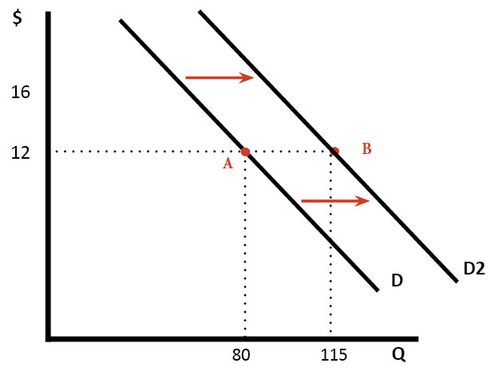
Figure: Increase in Demand — Rightward shift from D to D2 at the same price level (Price = 12, Qty: 80 → 115)
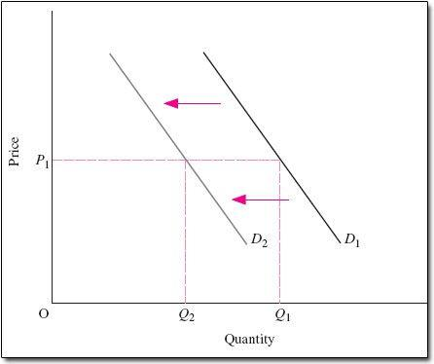
Figure: Decrease in Demand — Leftward shift from D1 to D2 (Quantity decreases at same price P1)
2.3 Types of Demand
Type | Definition | Agricultural Example
Autonomous Demand | No link with demand for other goods. | Demand for food staples like rice/wheat.
Derived Demand | Demand linked to demand for other goods. | Demand for fertilisers (derived from crop demand).
Price Demand | Various quantities willingly bought at all possible prices. | Farmer buying wheat seed at various market prices.
Income Demand | Quantities demanded at different income levels. | Higher income → more organic food bought.
Cross Demand | Quantities demanded due to price change in a related good. | Rise in price of butter → more demand for margarine.

2.4 Giffen Goods (Exception to Law of Demand)
🔑 Giffen Goods — Key Points
• Giffen goods are a special category of INFERIOR goods.
• They are an EXCEPTION to the Law of Demand.
• Demand DECREASES when price DECREASES (opposite to normal behaviour).
• Reason: The income effect dominates and is negative — as price falls, real income rises, and the consumer switches away from this inferior good.
• Examples: Bread, rice, and potatoes for subsistence-level consumers.
• Important Distinction: All Giffen goods are inferior goods, but NOT all inferior goods are Giffen goods.
• Giffen goods have no ready substitute or close alternative.

2.5 Elasticity of Demand
📖 Elasticity of Demand
"The degree of responsiveness or sensitiveness of quantity demanded to a change in its price (or income or price of related goods). Its value ranges from 0 to ∞."

A. Price Elasticity of Demand (Ed):
Ed = % Change in Quantity Demanded ÷ % Change in Price
Ed = (ΔQ/Q) × (P/ΔP)
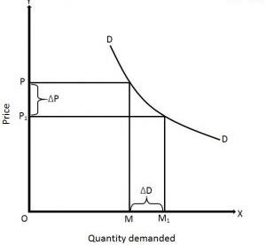
Figure: Price Elasticity of Demand — shows ΔP (change in price) and ΔD (change in quantity demanded)
B. Income Elasticity of Demand:
Ei = % Change in Quantity Demanded ÷ % Change in Income
C. Cross Elasticity of Demand:
Ec = % Change in Qty Demanded of Good X ÷ % Change in Price of Good Y
Five Categories of Price Elasticity
Category | Ed Value | Demand Curve Shape | Example | Graph
Perfectly Elastic | Ed = ∞ | Horizontal line (flat) | Salt at fixed price | See graph below
Perfectly Inelastic | Ed = 0 | Vertical straight line | Insulin for diabetics | See graph below
Relatively Elastic | Ed > 1 | Flatter curve | Luxury goods, gold | —
Relatively Inelastic | Ed < 1 | Steeper curve | Necessities (salt, kerosene) | —
Unitary Elastic | Ed = 1 | Rectangular hyperbola | Comforts | See graph below

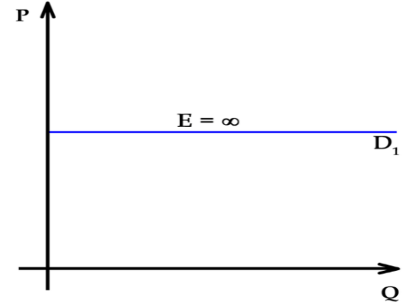
Figure: Perfectly Elastic Demand — Horizontal demand curve, Ed = ∞ (consumers buy any amount at one price)
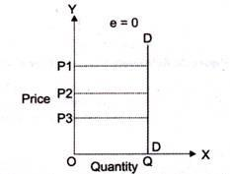
Figure: Perfectly Inelastic Demand — Vertical demand curve, Ed = 0 (quantity unchanged at any price)
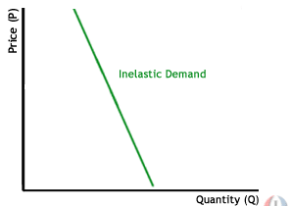
Figure: Relatively Inelastic Demand — Steep downward-sloping curve, Ed < 1 (small change in qty for large price change)
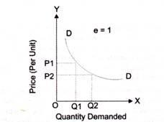
Figure: Unitary Elastic Demand — Ed = 1 (percentage change in price exactly equals percentage change in quantity)
2.6 Determinants of Price Elasticity of Demand
Determinant | Effect on Elasticity | Why
Nature of Commodity — Luxury | Ed > 1 (Elastic) | Can be postponed; substitutes often available.
Nature of Commodity — Necessity | Ed < 1 (Inelastic) | Cannot be avoided; no substitutes.
Nature of Commodity — Comfort | Ed = 1 (Unitary) | Between luxury and necessity.
Availability of Substitutes | More substitutes → Elastic | If price rises, switch to substitute.
Multiple Uses of Good | More uses → Elastic | Electricity, coal — used in many ways.
Postponement of Use | Postponable → Elastic | Gold, luxury cars — buy later.
Consumer Income — Rich/Poor | Inelastic | Price changes have little effect.
Consumer Income — Middle Class | Elastic | Price changes significantly affect budget.
Habit-forming Goods | Inelastic | Cigarettes, coffee — consumed regardless of price.
Time Period — Short Run | Inelastic | Habits cannot change quickly.
Time Period — Long Run | Elastic | Habits can change; alternatives emerge.

2.7 Supply Curves and Market Equilibrium
The supply curve shows a POSITIVE relationship between price and quantity supplied — as price rises, suppliers are willing to supply more.
➤ Supply curve slopes upward (left to right).
➤ Supply is a production-side concept influenced by: technology, input costs, number of sellers, government policy.
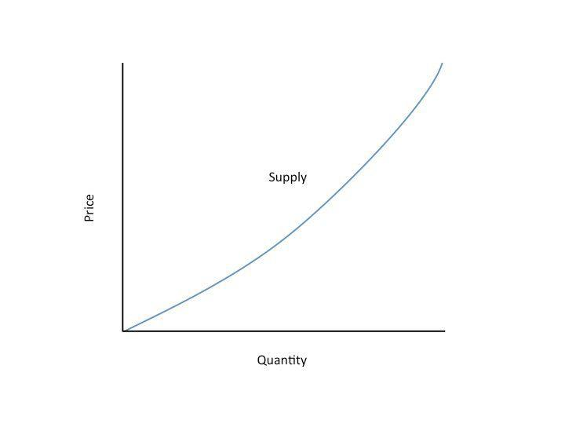
Figure: Supply Curve — Upward sloping, showing positive relationship between Price and Quantity supplied
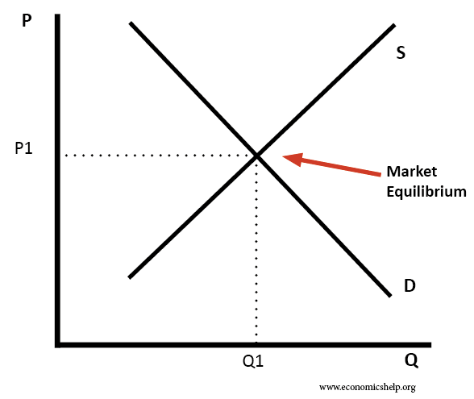
Figure: Market Equilibrium — Point (P1, Q1) where Demand (D) and Supply (S) curves intersect
📌 REMEMBER: Market Equilibrium: The price (P1) and quantity (Q1) at which the demand and supply forces intersect. It is the ONLY point where quantity demanded = quantity supplied. Any price above P1 causes surplus; any price below P1 causes shortage.

Chapter 3 — Cost Concepts
In any business activity, the details of costs and returns provide an idea of profitability. Cost of production refers to the expenses incurred in producing a unit quantity of a product in a particular time period. Cost functions can pertain to the short run or long run.
3.1 Short Run vs Long Run
Short Run | Long Run
At least one input is FIXED | ALL inputs are VARIABLE
Fixed costs exist | No fixed costs — all costs are variable
Firm cannot change plant size | Firm can change all factors
Time is insufficient to change all inputs | Sufficient time to adjust all inputs
E.g., Production with existing machinery | E.g., Building a new factory

3.2 Fixed Cost (FC)
📖 Fixed Cost
"Costs that do NOT vary with the level of output. They are incurred even if production is zero (cannot be avoided in the short run)."
— Economics

➤ Examples: Taxes, insurance premiums, depreciation on machinery and buildings, rent on land, interest on fixed capital.
➤ TFC curve is a horizontal straight line (constant at all output levels).
➤ As output increases, AFC = TFC/Q → AFC continuously FALLS (hyperbola shape).
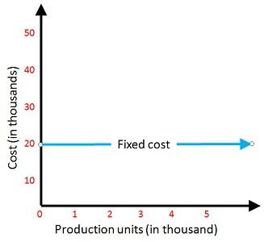
Figure: Fixed Cost (TFC) Curve — Horizontal straight line; cost stays constant at ₹20,000 regardless of output
3.3 Variable Cost (VC)
📖 Variable Cost
"Costs that VARY with the level of output. Zero when output is zero; increases as output increases."
— Economics

➤ Examples: Cost of raw materials, hired labour, power, repairs, seeds, fertilisers, pesticides, irrigation charges.
➤ TVC starts from zero and rises with output.
➤ TVC initially rises slowly (increasing returns), then faster (diminishing returns).
➤ Prime Cost = Variable Cost (another name).
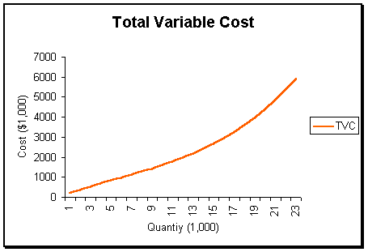
Figure: Total Variable Cost (TVC) Curve — Starts at zero, rises at an increasing rate as output expands
3.4 Total Cost (TC = TFC + TVC)
TC is the sum of Total Fixed Cost and Total Variable Cost at each output level.
Key property: The TC curve is parallel to TVC curve — separated by the constant TFC amount.
Output (Q) | TFC (₹) | TVC (₹) | TC (₹) | AFC (₹) | AVC (₹) | ATC (₹) | MC (₹)
0 | 10 | 0 | 10 | — | 0 | — | —
1 | 10 | 10 | 20 | 10.0 | 10.0 | 20.0 | 10
2 | 10 | 18 | 28 | 5.0 | 9.0 | 14.0 | 8
3 | 10 | 24 | 34 | 3.3 | 8.0 | 11.3 | 6
4 | 10 | 28 | 38 | 2.5 | 7.0 | 9.5 | 4
5 | 10 | 32 | 42 | 2.0 | 6.4 | 8.4 | 4
6 | 10 | 38 | 48 | 1.7 | 6.3 | 8.0 | 6
7 | 10 | 46 | 56 | 1.4 | 6.6 | 8.0 | 8
8 | 10 | 62 | 72 | 1.2 | 7.8 | 9.0 | 16

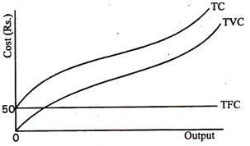
Figure: TC, TVC, TFC Curves Together — TC and TVC are parallel; TFC is horizontal at ₹50
3.5 Average Variable Cost (AVC)
AVC = TVC ÷ Q (Variable cost per unit of output)
Shape: U-shaped curve — initially falls due to increasing returns, reaches minimum, then rises due to diminishing returns.
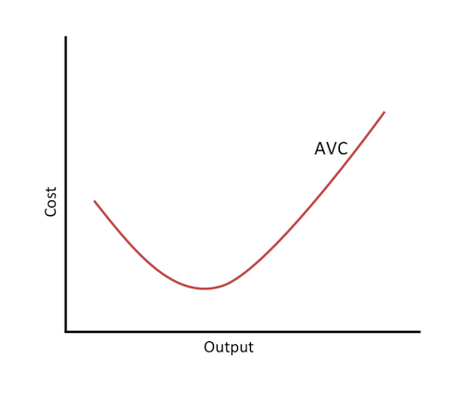
Figure: AVC Curve — U-shaped; falls initially then rises due to diminishing returns
3.6 Average Fixed Cost (AFC)
AFC = TFC ÷ Q (Fixed cost per unit of output)
Shape: Continuously declining (hyperbola) — as more units are produced, the same fixed cost is spread across more units.
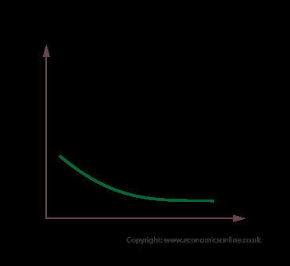
Figure: AFC Curve — Continuously declining hyperbola; approaches X-axis but never touches it
3.7 Average Total Cost (ATC) and Marginal Cost (MC)
ATC = TC ÷ Q = AFC + AVC
Shape: U-shaped (influenced by both AFC and AVC).

MC = ΔTC ÷ ΔQ = ΔTVC ÷ ΔQ
MC is the change in total cost (or TVC) due to one more unit of output.
Fixed cost has NO effect on MC — since FC does not change, only TVC changes.
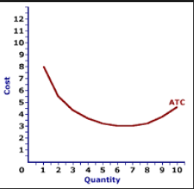
Figure: ATC Curve — U-shaped; reaches minimum at output = 7 (Cost ≈ 3.5)
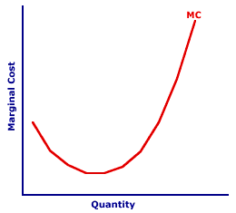
Figure: Marginal Cost (MC) Curve — U-shaped; falls then rises sharply at higher output
3.8 Combined Cost Curve Analysis
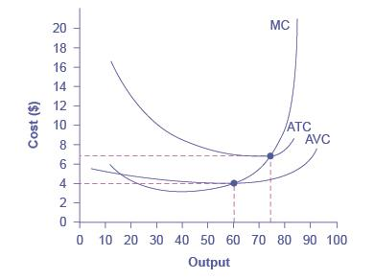
Figure: Combined MC, ATC, AVC Curves — MC intersects AVC at AVC minimum (Q≈60) and ATC at ATC minimum (Q≈75)
🔑 Critical Rules for Combined Cost Curves
• MC curve intersects AVC at its MINIMUM POINT.
• MC curve intersects ATC at its MINIMUM POINT.
• When MC < AVC, AVC is falling. When MC > AVC, AVC is rising.
• When MC < ATC, ATC is falling. When MC > ATC, ATC is rising.
• AFC continuously declines and never reaches zero.
• ATC = AVC + AFC; as output increases, ATC approaches AVC (since AFC → 0).
• Marginal Cost is ALWAYS a Variable Cost — fixed costs do not change with output.

📌 REMEMBER: Important Exam Point: MC = AVC = ATC at their respective minimum points. The MC curve is like a skewer through the bottom of both U-shaped bowls (AVC and ATC).

Chapter 4 — Rural Credit and Agriculture Finance
📖 Credit
"Derived from the Latin word CREDO meaning "I believe" or "I have confidence in". In economics, credit implies the postponement of payment."
— Classical Definition

"Farm finance is concerned with the acquisition and management of capital in the farm business."
➤ Finance: Borrowed funds only.
➤ Credit: Combination of OWNED funds + BORROWED funds.
➤ 54% of India's population is dependent on agriculture — making agricultural finance critical.
➤ Levels: Agricultural Finance exists at two levels:
◆ Macro Finance: Deals with sources of funds for agriculture as a WHOLE in the economy.
◆ Micro Finance: Deals with financial management of INDIVIDUAL farm businesses.
◆ Credit is needed for: new technology adoption, machinery purchase, land development, and input procurement.
4.1 Classification of Credit
Type | Repayment Period | Purpose | Examples
Short-Term Credit | Up to 12 months | Current farm operating expenses | Seeds, manure, fertilisers, hired labour wages, pesticides
Medium-Term Credit | 1 to 3–5 years | Semi-permanent investments | Tractor purchase, tube well installation, farm building construction, livestock purchase
Long-Term Credit | More than 5 years | Permanent capital investments | Land purchase, major irrigation projects, land reclamation, special development projects

🔑 Memory Tip for Credit Types
• Short: Up to 12 months — Seeds, fertilisers (annual crop cycle).
• Medium: 1–5 years — Tractors, tube wells (medium-life assets).
• Long: > 5 years — Land purchase, major projects (permanent capital).

4.2 Cooperative Movement in India — Historical Stages
Stage | Period | Key Events
Initiation Stage | 1904–1911 | Cooperative Credit Societies Act enacted (1904). Father: F. Nicholson.
Modification Stage | 1912–1918 | Refinements to cooperative legislation.
Expansion Stage | 1919–1929 | Rapid growth of cooperative societies across India.
Restructuring Stage | 1930–1946 | Reforms to address weaknesses; cooperative planning committee formed (1945), report submitted 1946.
Post-Independence | 1947 onwards | All-India Rural Survey Committee report (1951), Chairman: A. D. Gorwala.

Chapter 5 — Important Banking and Finance Institutions
🏦  RESERVE BANK  OF INDIA  (RBI) | Established: 1st April 1935 (RBI Act, 1934)  Nationalised: 1st January 1949  Headquarter: Mumbai  Role: Central Bank of India  Note Issue: Issues all denomination notes EXCEPT ₹1 coin/note and small coins  Functions: Banker to Government | Banker to Banks | Credit Control | Foreign Exchange Control

🌾  REGIONAL RURAL  BANKS  (RRBs) | Established: 2nd October 1975 (First 5 set up on pilot basis)  Current Count: 43 Regional Rural Banks functioning  Purpose: Provide institutional credit to weaker sections — farmers, artisans, rural labourers  Targets: Small and marginal farmers, rural artisans, agricultural labourers  Credit Facility: Short, medium, and long-term credit for agriculture and allied activities  Single Window System: First started in Andhra Pradesh

🏛️  NABARD  (National Bank for  Agri & Rural Dev.) | Established: 12 July 1982  Paid-up Capital: ₹30,000 Crores  Headquarter: Mumbai  Role: Apex body for rural finance and agricultural development  Refinance to: State Land Dev. Banks | State Co-op Banks | Scheduled Commercial Banks | RRBs  Fund Sources: Government of India, World Bank, other international agencies  Objective: Promote agricultural and rural prosperity through credit and development

📌 REMEMBER: KCC (Kisan Credit Card): Under new rules, a bank MUST provide a KCC to a farmer within 2 WEEKS of receiving the application. | Taccavi Loans: Government advances to cultivators during British period. | Microcredit: Small loans provided by banks to low-income clients.

Chapter 6 — International Organizations and Institutions
Organization | Est. Year | HQ | Key Role / Objective
International Monetary Fund (IMF) | 22 July 1944  (Operations: 1 March 1947) | Washington DC, USA | International monetary cooperation; balance of payments assistance; financial stability.
World Bank (IBRD) | July 1944  (Operations: June 1946) | Washington DC, USA | Provides loans for economic development and reconstruction.
World Trade Organization (WTO) | April 1994 (GATT Uruguay Round)  Formal: 1 Jan 1995 | Geneva, Switzerland | Facilitate & regulate international trade; dispute resolution; multilateral trade agreements.
Asian Development Bank (ADB) | December 1966  (Operations: Jan 1967) | Manila, Philippines | Lending to Asian countries at concessional interest rates for development.
Food & Agriculture Organization (FAO) | 16 October 1945 | Rome, Italy | Raise living standards; improve rural conditions; increase production & distribution.
EXIM Bank of India | 1 January 1982 | Mumbai, Maharashtra | Financial assistance to Indian exporters and importers.

6.1 FAO — Additional Details
➤ Director General: Elected for a period of 6 years.
➤ Works toward: food security, sustainable agriculture, eradication of hunger, poverty, and malnutrition.
➤ India is a founding member of FAO.
6.2 WTO — Additional Details
➤ Successor to GATT (General Agreement on Tariffs and Trade).
➤ Functions: Implement and administer multilateral trade agreements; act as a forum for trade negotiations; collaborate with IMF and World Bank for global economic policy coherence.
6.3 EXIM Bank — Additional Details
➤ Full name: Export Import Bank of India.
➤ Overseas offices: Washington (USA), Singapore, Abidjan (Ivory Coast), Budapest (Hungary).
➤ Promotes Indian exports and facilitates two-way trade.

Chapter 7 — Agricultural Marketing
📖 Agricultural Marketing
"A process in which the seller of agricultural commodities wishes to sell his goods and the buyer desires to buy that commodity at a fixed (agreed) price."
— Standard Definition

The word "market" is derived from the Latin word MARCATUS, meaning merchandise, trade, or a place where business is conducted.
"Marketing is the performance of all business processes, including the delivery of goods and services from the initial agricultural production point to the final (consumer) point."
7.1 Utility Added by Marketing
Marketing adds cost to the product but simultaneously creates four types of utility:
Utility Type | Marketing Function | Example
📦 Form Utility | Processing function — changing raw material to finished form | Processing paddy into rice; converting milk into butter/ghee.
🚛 Place Utility | Transportation — moving from surplus to deficit areas | Transporting apples from Himachal Pradesh to Delhi markets.
🕐 Time Utility | Storage — making goods available at the right time | Cold storage of potatoes during harvest for sale in off-season.
🤝 Possession Utility | Buying and selling — transfer of ownership | Farmer selling wheat to a trader; trader selling to mill.

7.2 Market Structures — Detailed Comparison
Feature | Perfect Competition | Monopolistic Competition | Monopoly | Oligopoly
No. of Sellers | Very Large (many) | Large (many) | ONE | Few (2 or more)
Product Type | Homogeneous (identical) | Heterogeneous (differentiated) | Both possible | Similar or differentiated
Price | Uniform (price taker) | Non-uniform (price maker) | Non-uniform | Non-uniform
Entry of Firms | Free (no barriers) | Not absolute freedom | Not possible (blocked) | Difficult
Market Knowledge | Perfect (all info available) | Imperfect | Imperfect | Imperfect
Mobility | Perfect | Imperfect | Imperfect | Imperfect
Demand Curve | AR = MR (horizontal) | AR > MR | AR > MR | AR > MR
Selling Cost | Not required | Often required (ads) | Seldom required | Often required
Example | Agricultural commodity | Branded fertilisers | Single utility provider | Telecom companies

📌 REMEMBER: Monopoly = Single seller | Monopsony = Single buyer | Oligopoly = Few sellers | Oligopsony = Few buyers | Monopolistic = Large sellers with heterogeneous products | Perfect Competition = Large sellers with homogeneous products.

7.3 Classification of Agricultural Markets
A. According to Seller:
Market Type | Location | Participants | Key Features
Primary Market (Hats) | Villages | Producers + Consumers + Itinerant dealers | Held once/twice a week; direct farm-to-consumer sales.
Secondary Market | Cities/District HQ | Wholesalers, Kaccha & Pucca Arhatiyas | Daily markets; wholesale trade predominates.
Tertiary/Terminal Market | Seaports/Railheads | Exporters, large traders | For export of agricultural products to other countries.

B. According to Time:
➤ Daily Market: Very short period; demand determines price (supply is fixed/limited).
➤ Short Period Market: Supply cannot be fully adjusted; demand plays a dominant role.
➤ Long Period Market: Supply can be adjusted to match demand by changing production levels.
C. According to Competition:
➤ Perfect Market: Many buyers and sellers; full price knowledge; free competition.
➤ Imperfect Market: Friendship, limited buyers/sellers, incomplete price information.
➤ Monopoly Market: Single producer/seller; no close substitutes; price-maker.
D. According to Regulation:
➤ Regulated: Regulated Market: Governed by Market Regulation Act; middlemen licensed; fixed charges; metric weighing.
➤ Unregulated: Unregulated Market: No government oversight; all marketing defects present; middlemen charge excessively.
E. Methods of Sale:
Method | Description | Used For
Open Auction | Buyers openly bid; highest bidder wins | Grain, vegetables
Private Agreement/Treaty | Individual negotiations between buyer and seller | Bulk commodity deals
Dara Sales | Mixed-quality heaps sold at a flat rate | Low-grade grain
Close Tender System | Sealed tenders invited; highest accepted | Government procurement
Sale by Sample | Product samples sent for display and approval | Cotton, wool, wheat
Sale by Grade | Product divided into grades; sold by grade name/mark | AGMARK-graded products

🏷️ AGMARK: Agricultural Marketing Grade — an indicator of purity and quality standard for agricultural commodities. Agricultural Produce (Grading & Marketing) Act was passed in 1937. Grade standards are fixed by the Agricultural Marketing Advisor, Government of India.

7.4 Marketing Channels
A market channel is the route by which a commodity passes from producers to ultimate consumers.
Channel | Route | Type
Channel 1 (Shortest) | Producer → Consumer | Direct marketing / Farmers' market
Channel 2 | Producer → Retailer → Consumer | Semi-direct
Channel 3 | Producer → Wholesaler → Retailer → Consumer | Indirect
Channel 4 (Longest) | Producer → Village Trader → Commission Agent → Wholesaler → Retailer → Consumer | Most indirect

7.5 Producers Surplus
Marketable Surplus | Marketed Surplus
What SHOULD be available to non-farm population | What the farmer ACTUALLY sells in the market
Formula: MS = P − C (Production − Requirements) | Irrespective of farmer's own requirements
Residual after meeting family, farm, and feed needs | Can be more OR less than marketable surplus
If Marketed > Marketable → DISTRESS SALE | Distress Sale: Price < Cost of Production
For perishable goods: Marketable = Marketed surplus | For storable goods: they may differ

Factors Affecting Marketable Surplus:
◆ Size of farm holding
◆ Total production level
◆ Price of the commodity
◆ Family size and consumption needs
◆ Seed and feed requirements
◆ Nature of commodity (perishable vs storable)
◆ Consumption habits of the farmer family
7.6 Marketing Costs — Detailed Components
Marketing costs include all expenses from farm gate to the consumer:
Cost Component | Description
Assembling/Collection | Bringing produce from scattered farms to a collection point
Transportation | Moving goods from production to consumption areas (Place Utility)
Storage | Preserving goods for future sale (Time Utility)
Processing | Converting raw produce to marketable form (Form Utility)
Grading & Standardisation | Sorting produce by quality/grade
Packaging | Protective covering for safe transport and storage
Market charges | Commission, brokerage, cess, etc.
Risk and Insurance | Losses from spoilage, fire, price fall, etc.
Advertisement | Demand creation and brand promotion
Interest on capital | Cost of funds invested in marketing
Sales service | Home delivery, return facility, credit to buyers
Market information | Cost of obtaining price and demand data

💻 e-NAM (National Agriculture Market) was launched on 14th April 2016 — an online trading platform for agricultural commodities to create a unified national market.

Chapter 8 — Farm Management
📖 Farm Management
"The method of applying the principles underlying the selection, organization, and operation of a farm industry, so that as much profit as possible can be obtained."
— Adams

📖 Farm Management (Tandon & Dhodhiyal)
"A branch of agricultural economics that studies the activities of earning and spending money by a farmer, concerned with the organization, operation, and marketing of the farm."

8.1 Objectives of Farm Management
1. Primary Objective: Reduce cost, loss, damage, inefficiency, and unemployment; increase profit, productivity, efficiency, and employment.
2. Resource Study: Study available resources — land, labour, capital, management — and the pattern of production.
3. Relationship Analysis: Understand relationships between different inputs and outputs.
4. Decision Making: Help farmers decide: WHAT to produce, HOW to produce, HOW MUCH to produce, WHEN to produce, and WHEN to sell.
5. Commercial Success: Enable farmers to make profitable decisions in the commercial management of agriculture.
🔑 Four Key Decisions in Farm Management
• WHAT to produce? → Guided by Product-Product Relationship.
• HOW to produce? → Guided by Factor-Factor Relationship (Least Cost Combination).
• HOW MUCH to produce? → Guided by Factor-Product Relationship (Input-Output analysis).
• WHEN to sell? → Guided by market prices, seasonality, and storage capacity.

8.2 Principles of Farm Management
Principle | Core Concept | Application in Farming
1. Law of Diminishing Returns (LDR) | Each additional unit of input yields less additional output beyond a point. | Determine optimal level of fertiliser/irrigation application.
2. Factor Substitution | Replace one input with another more efficiently. | Replace bullock labour with tractor; find least-cost input combination.
3. Product Substitution | Switch between crops/products for higher returns. | Replace low-value crop with high-value cash crop.
4. Minimum Cost Principle | Achieve required output at the lowest possible cost. | Selecting among irrigation methods; choosing fertiliser mix.
5. Comparative Advantage | Specialise in production where you have lower relative cost. | Sugarcane near sugar mill; vegetables near cities.
6. Opportunity Cost | Cost of the next best alternative foregone. | Cost of growing wheat = what could have been earned by growing pulses on that land.
7. Equi-Marginal Returns | Allocate limited resources so MVP is equal across all uses. | Allocating water, labour across multiple crops for equal marginal return.

8.3 Key Relationships in Farm Management
Relationship Type | Helps Decide | Key Concept | Tools Used
Factor–Product | HOW MUCH to produce | Input-Output Relationship = Production Function | Marginal Product (MP), Average Product (AP)
Factor–Factor | HOW to produce | Least Cost Combination of inputs | Isoquants, Iso-cost lines, MRS, Price ratio
Product–Product | WHAT to produce | Profit maximisation across enterprises | Production Possibility Curve, Enterprise Combinations

8.4 Production and Factors of Production
📖 Production
"The process by which inputs (goods and services) are converted into outputs (other goods and services) that create utility."

Factor | Description | Key Features | Reward
🌍 Land | Natural resource; primary input in agriculture. | Gift of nature; stable in quantity; permanent; immovable; variable fertility; Geographical supply fixed but economic supply can be increased. | Rent
👷 Labour | Any physical or mental work done for monetary compensation. | Cannot be separated from the worker; short-run supply inelastic; active factor; perishable (cannot be stored). | Wages
💰 Capital | Man-made resource used to create future wealth. | All capital is wealth but not all wealth is capital; farm buildings = capital + wealth; residential buildings = only wealth. | Interest
🏢 Organisation | Entrepreneurial function — combining and managing all other factors. | Takes risks; makes decisions; creates and manages the enterprise. | Profit / Benefit

8.5 Important Farm Holding Concepts
Concept | Definition | Size Criterion
Farm | Area under single management system for crop/livestock enterprises. | Specific boundaries
Agricultural Holding | Total land OWNED (cultivated or rented out) by an individual/joint family. | No specific size
Operational Holding | Total area under single management for cultivation (excludes leased-out land). | No specific size
Family Holding | Farm providing: Gross income = ₹1,600; Net income = ₹1,200. | Income-based
Optimum Holding | Maximum holding a family should possess = 3 × Family Holding. | 3 × Family Holding
Economic Holding | Provides reasonable standard of living + full employment for the farm family. | Income + employment
Marginal Farmer | Very small farmer. | < 1 ha (< 2.5 acres)
Small Farmer | Small farmer category. | 1 ha to 2 ha

8.6 Law of Diminishing Returns (LDR)
📖 Law of Diminishing Returns
"After a certain stage, the application of successive doses of labour and capital to a given area of land brings about a less-than-proportionate increase in output."
— Classical Economics

➤ Also known as: Law of Variable Proportions | Law of Increasing Costs.
➤ BASIC fundamental law of agriculture — used to explain input-output relationship.
➤ At optimum profit: MC = MR (Marginal Cost = Marginal Revenue).
➤ If MP > MC: Further investment is PROFITABLE — keep adding inputs.
➤ If MP < MC: Further investment is UNPROFITABLE — reduce input.
➤ If MP = MC: OPTIMAL POINT — maximum profit achieved.
📌 REMEMBER: LDR applies more generally to the Agricultural Industry because land is fixed. Three stages of LDR: Stage I (Increasing returns), Stage II (Diminishing returns — optimal production zone), Stage III (Negative returns — never produce here).

8.7 Types of Farming
Type | Definition | Income Source | India Example
Specialised | ≥ 50% of income from ONE enterprise. | One main crop or livestock | Plantation farming in Assam (tea) or Nilgiri (coffee)
Diversified (General) | < 50% income from ANY single source. | Multiple crops and activities | Mixed crop farming in UP, Punjab plains
Mixed Farming | Crops + Livestock integrated. | Crops and livestock combined | Dairy farming alongside cereal crops
Dry Farming | In areas with ≤ 75 cm rainfall; no irrigation. | Dryland crops | Jowar, bajra in Rajasthan, Deccan plateau
Ranching | Extensive livestock on large natural grazing areas. | Meat, wool, milk | Sheep rearing in hilly areas

8.8 Specialized vs. Diversified Farming
Specialized Farming | Diversified Farming
One or two enterprises operated on farm | Multiple enterprises on the farm
≥ 50% income from the main enterprise | < 50% income from each enterprise
Main source of income is concentrated | Income distributed among many sources
Requires specialised/expert knowledge | General knowledge across disciplines
Uses specialised machinery and tools | Common farming methods and tools
Goods mainly produced for MARKET SALE | Goods often produced for family consumption
Higher risk (single-crop failure = total loss) | Lower risk (diversification reduces risk)
Managed on industrial/commercial principles | Managed as a family livelihood activity
Example: Tea estate, sugarcane farm | Example: General crop + dairy + poultry farm

8.9 Systems of Farming
System | Key Features | Where Practised
Peasant Farming | Small scale; family labour; subsistence-oriented; limited capital. | Most of India
Co-operative Farming | Farmers pool land and resources; joint cultivation; shared profits. | Limited in India
Capitalistic Farming | Large-scale; hired labour; profit motive; heavy machinery. | Punjab, Haryana, some plantation areas
Collective Farming | State-owned land; collective work; state controls production. | Russia, China (historically)
State Farming | Government owns and manages the farm. | State farms in socialist economies

8.10 Principle of Opportunity Cost
📖 Opportunity Cost (Alternative Cost)
"The value of the next best alternative foregone when a resource is used for a given purpose."
— Economics

➤ Example: If a farmer grows wheat on his land, the opportunity cost is the income he could have earned by growing rice on that same land.
➤ Important: Opportunity cost is NOT a monetary expenditure — it is a FOREGONE BENEFIT.
➤ Relevant in farm planning: choosing between crops, deciding whether to rent out or cultivate land.
8.11 Principle of Combining Enterprises
Enterprise Relationship | Definition | Effect on Output | Example
Independent | No direct effect on each other. | Change in one does NOT affect the other. | Poultry and fishery on same farm (use different resources).
Competitive | Compete for the SAME limited resources. | Increase in one DECREASES the other. | Wheat and mustard competing for same plot.
Complementary | Increase in one INCREASES the other. | Positive mutual benefit (no resource competition). | Legume + Cereal rotation (legume fixes nitrogen for cereal).
Supplementary | Increase in one does NOT affect the other (uses idle resources). | No conflict; one uses surplus resources. | Backyard poultry using kitchen waste; fodder crop in field borders.

Chapter 9 — Depreciation
📖 Depreciation
"The decline in the value of an asset due to usage, accidental damage, passage of time, or obsolescence."
— Accounting / Farm Management

➤ Junk Value (Scrap/Salvage Value): The remaining value of an asset at the END of its useful life when it is completely worn out.
➤ Book Value: Value obtained by deducting annual depreciation from the original cost each year.
➤ Depreciation is included in FIXED COSTS in farm budgeting.
9.1 Methods of Depreciation — Detailed Comparison
Method | Formula | Best Used For | Key Characteristic
Straight Line Method | Annual Depreciation = (Original Cost − Junk Value) ÷ Useful Life | Machinery, tools, buildings | Equal depreciation every year; simple to calculate.
Diminishing Balance Method | Annual Depreciation = Book Value × Depreciation Rate (R) | Vehicles, tractors, equipment | Higher depreciation in early years; decreasing each year.
Sum of the Years Digit Method | Annual Dep. = (OC − JV) × (Remaining life ÷ Sum of digits) | Assets with faster early decline | Accelerated depreciation; more complex calculation.
Annual Revaluation Method | Depreciation = Beginning Value − End-of-Year Value | LAND and LIVESTOCK in agriculture | Based on actual market revaluation each year.

🔑 Depreciation — Memory Points
• Annual Revaluation Method is specifically used for LAND and LIVESTOCK in agriculture.
• Straight Line Method: Same depreciation every year (most common for buildings).
• Diminishing Balance: More depreciation in early years (used for tractors, vehicles).
• Land rent is an example of FIXED COST.
• Depreciation on machinery and buildings is also a FIXED COST.
• IRDP (Integrated Rural Development Programme) was started on 2 October 1980.

Chapter 10 — Farm Planning and Budgeting
📖 Farm Planning
"A process or technique for making plans about the optimum choice and combination of farm enterprises. A farm plan is the complete scheme for the operation and organisation of a farm business."

📖 Farm Budgeting
"The physical aspects of farm planning expressed in monetary terms. It provides a detailed statement of estimated costs and returns."

📋 Preparing a farm budget IN ADVANCE is known as Farm Planning. Farm planning serves as the BASIS for farm budgeting.

10.1 Factors Affecting Farm Planning
Factor | What to Assess | Why Important
Land | Quality, quantity, soil types, location, fertility status, irrigation availability. | Determines what crops can be grown and at what yield.
Labour | Availability of family and hired labour; bullock power; seasonal labour needs. | Labour is often a critical constraint in farm planning.
Capital | Inventory of buildings, livestock, machinery, equipment; credit needs. | Available capital limits investment in new enterprises.
Management | Farmer's knowledge, experience, skill, and decision-making ability. | Determines the complexity of farming system that can be managed.
Market Conditions | Prices, demand, storage and transport infrastructure. | Profitability depends on market access and price levels.
Government Policy | MSP, subsidies, credit schemes, insurance programmes. | Policy support can significantly alter profitability of enterprises.

10.2 Partial Budgeting
📖 Partial Budget
"A detailed description of the income and expenditure of a SINGLE enterprise, a few enterprises, or a PART of the total farm.
Net Return (R) = (Qy × Py) − (X₁Px₁ + X₂Px₂ + … + XnPn) − Fixed Cost"

Advantages of Partial Budgeting:
➤ Simple, quick, and easy to prepare.
➤ Provides a clear indication of profitability of a particular enterprise.
➤ Helps in utilising a specific resource most effectively.
➤ Can be used to update total budgets without completely reworking them.
➤ Useful for comparing costs/returns of alternative practices (e.g., bullock vs. tractor power).
➤ Concentrates attention on a single enterprise for fuller problem analysis.
10.3 Complete Budgeting
📖 Complete Budget
"A detailed statement of estimated costs and returns for the ENTIRE FARM as a complete unit.
Net Return (R) = [Σ(Qy × Py)] − [Σ(Xn × Pxn)] − Fixed Cost"

Advantages of Complete Budgeting:
➤ Considers the farm as a single unit — all resources and enterprises simultaneously.
➤ Allows for substitution relationships between resources.
➤ Accounts for complementary, supplementary, and competitive relationships between enterprises.
➤ Draws attention to all factors affecting farm earnings.
➤ Allows comparison of total probable earnings under different enterprise combinations.
➤ Avoids the difficulty of allocating joint costs between enterprises.
10.4 Steps in the Farm Budgeting Process
Step | Activity | Detail
Step 1 | Inventory of farm resources | Assess all assets: land area, soil quality, farm buildings, livestock, machinery, and equipment.
Step 2 | Assess capital position | Determine the farmer's financial position and identify credit requirements.
Step 3 | Identify credit sources | Assess availability of loans from banks, cooperatives, NABARD, RRBs, etc.
Step 4 | Labour assessment | Determine availability of family labour, hired labour, and bullock/machine power by season.
Step 5 | Analyse present operations | Calculate current costs and returns to establish a baseline for future improvement.
Step 6 | Develop alternative plans | Prepare several alternative farm plans and select the best one considering all limitations.

10.5 Uses of Farm Planning and Budgeting
➤ Serves as a yardstick for agricultural credit — helps banks decide loan amounts.
➤ Essential for formulating and appraising development projects.
➤ Provides a roadmap to the farmer's financial security.
➤ Provides basis for calculating economic viability of farm enterprises.
➤ Helps in evaluating the impact of new technology adoption.
➤ Enables comparison of farm performance over time.

Chapter 11 — Important Facts and Quick Revision
⚡ This chapter contains all the high-frequency exam facts from the original PDF, organized by topic for fast revision.

📊 Economics — Basics
✦ Father of Economics: ADAM SMITH | Father of Modern Economics: J. M. KEYNES.
✦ Ragnar Frisch coined the terms "Microeconomics" and "Macroeconomics".
✦ "Arthashastra" is the Indian equivalent of Economics — by Chanakya.
✦ A positive science deals with "what IS"; a normative science with "what OUGHT to be".
✦ "Economic laws" — statements of uniformities governing human behaviour w.r.t. limited resources — Robbins.
✦ Input-Output relationship = PRODUCTION FUNCTION.
✦ The maximum output from given inputs per time period = Production Function.
✦ Anything that satisfies a human want = GOOD. Work done by a person = SERVICE.
✦ All capitals are wealth, but all wealth is not necessarily capital.
✦ Producer goods = Goods of 2nd order; Consumer goods = Goods of 1st order.

📉 Demand & Elasticity
✦ When Total Utility is MAXIMUM → Marginal Utility is ZERO.
✦ Law of Diminishing Marginal Utility is applicable to AGRICULTURE.
✦ Giffen goods are rare inferior goods with no ready substitute (bread, rice, potatoes).
✦ Giffen goods are inferior goods — but NOT all inferior goods are Giffen goods.
✦ Elasticity of matchbox (necessity): Relatively inelastic (Ed < 1).
✦ Perfectly elastic demand: Demand curve is HORIZONTAL → Ed = ∞.
✦ Perfectly inelastic demand: Demand curve is VERTICAL → Ed = 0.
✦ For relatively elastic demand: Ed > 1 (luxuries, goods with substitutes).
✦ For relatively inelastic demand: Ed < 1 (necessities, habit-forming goods).
✦ Unitary elastic demand: Ed = 1 (comforts).
✦ Demand is INELASTIC in short run; ELASTIC in long run.
✦ Cross elasticity: change in demand for Good X due to price change in Good Y.
✦ If income elasticity > 1 → commodity is a LUXURY good.
✦ Consumer equilibrium: Marginal Utility / Price must be equal for all goods consumed.
✦ Indifference curve is always CONVEX to the origin.
✦ Autonomous demand: No link with other goods (food staples).
✦ Derived demand: Demand linked to demand for other goods (fertilisers derived from crop demand).
✦ The term OLIGOPOLY means two or more sellers of a commodity.

💰 Cost Concepts
✦ TC = TFC + TVC | ATC = AFC + AVC | MC = ΔTC/ΔQ = ΔTVC/ΔQ.
✦ MC intersects AVC and ATC at their MINIMUM POINTS.
✦ Fixed costs: Taxes, insurance, depreciation, land rent (constant regardless of output).
✦ Variable costs: Labour, seeds, fertilisers, pesticides, irrigation (vary with output).
✦ Prime cost = Variable cost (another name).
✦ Land rent is an example of FIXED COST.
✦ Livestock insurance is included in VARIABLE COST.
✦ Cost of Cultivation: Total expenditure per unit area (₹/ha).
✦ Cost of Production: Total expenditure per unit output (₹/quintal or ₹/tonne).
✦ Marginal cost is always a VARIABLE COST.
✦ Price which covers both variable and fixed costs = LONG RUN PRICE.
✦ Sub-normal price is a SHORT PERIOD price.

🏦 Credit, Banking & Finance
✦ RBI established: 1 April 1935 | Nationalised: 1 January 1949 | HQ: Mumbai.
✦ RBI issues all denomination notes EXCEPT ₹1 coin/note and small coins.
✦ 14 major banks nationalised: 19 July 1969. 6 more: 15 April 1980.
✦ RRBs established: 2 October 1975. Currently 43 RRBs functioning.
✦ NABARD established: 12 July 1982. HQ: Mumbai. Paid-up capital: ₹30,000 crore.
✦ SBI headquarters: Mumbai.
✦ Cooperative movement started: 1904. Father: F. Nicholson.
✦ Single Window Credit System: First started in Andhra Pradesh.
✦ Crop Loan System: First started in Andhra Pradesh.
✦ Agricultural Finance Corporation was promoted by Indian Banks Association (IBA).
✦ KCC to farmers: Bank must provide within 2 WEEKS of application.
✦ Taccavi Loans: Government advances to cultivators during British period.
✦ Microcredit: Small loans provided by banks to low-income clients.
✦ The term credit is from Latin word "Credo/Credere/Creditum" = loan / I trust you.
✦ First RRB on pilot basis set up on 2 October 1975 (target: marginal, small farmers, agri labourers).
✦ NABARD = apex agency for rural finance. RBI = central bank of India.
✦ Inflation calculated by: Consumer Price Index (CPI).

🌾 Agricultural Marketing
✦ Market from Latin word MARCATUS = merchandise / trade / place of business.
✦ AGMARK = indicator of purity and quality for agricultural commodities.
✦ Agri Produce (Grading & Marketing) Act: passed in 1937.
✦ Grade standards fixed by: Agricultural Marketing Advisor, GOI.
✦ Warehousing Corporations Act came into operation: 18 March 1962.
✦ e-NAM (National Agriculture Market) launched: 14 April 2016.
✦ The FIRST function in marketing of agri commodities: PACKING.
✦ Harvesting is NOT a function of marketing.
✦ Secular markets are PERMANENT in nature (manufactured goods — TV, machinery).
✦ Secondary wholesale markets are at DISTRICT HEADQUARTERS.
✦ Terminal/Tertiary markets are found at seaports/railheads (for export).
✦ Marketable Surplus = P − C (Production − Requirements).
✦ For PERISHABLE commodities: Marketable Surplus = Marketed Surplus.
✦ Distress Sale: When Marketed Surplus > Marketable Surplus (selling against own interest).
✦ Distress Sale also = Selling Price < Cost of Production.
✦ Market margin = PROFIT OF MIDDLEMEN.
✦ Price Spread = Price paid by consumer − Price received by farmer.
✦ Consumer Surplus = Maximum willingness to pay − Actual market price.
✦ Consumer Surplus = Difference between value-in-use and value-in-exchange.
✦ Marketing integration = Expansion of firms by consolidating marketing functions under single management.
✦ Market segmentation = Division of market into different homogeneous consumer groups.
✦ Direct marketing = Farmers' markets.
✦ Balance sheet provides NET WORTH of a business/farm.
✦ Life blood of market = MARKET INFORMATION.
✦ Most effective way to overcome marketing defects = REGULATING MARKETING.
✦ Dumping activity is seen under MONOPOLY.

🚜 Farm Management & Production
✦ Factor-Product Relationship: Decides HOW MUCH to produce.
✦ Factor-Factor Relationship: Decides HOW to produce.
✦ Product-Product Relationship: Decides WHAT to produce.
✦ LDR (Law of Diminishing Returns) = Law of Variable Proportions = Law of Increasing Costs.
✦ LDR is the BASIC fundamental law of agriculture.
✦ At optimum profit: MC = MR.
✦ If MP > MC → further investment is PROFITABLE.
✦ If MP = 0 → Total Production is at its MAXIMUM.
✦ Technical efficiency = Ratio of Output to Input.
✦ Isoquant = Equal quantity — same level of output from different input combinations.
✦ Iso-cost line (Budget line/Price line) = all input combinations purchasable with given budget.
✦ Expansion path (Isocline) = Line joining all least-cost combination points.
✦ Ridge line = Line joining the endpoints of isoquants.
✦ Principle of equi-marginal returns applied when RESOURCES ARE LIMITED.
✦ Joint products: Two products from the same production process (e.g., paddy + straw).
✦ Complementary product: Increase in one → increase in the other.
✦ Mixed farming: Livestock contribution to gross farm income ≥ 25–49%.
✦ Increase in money supply + Fall in production = INFLATION.
✦ IRDP (Integrated Rural Development Programme) started: 2 October 1980.
✦ EXIM Bank of India set up: 1 January 1982.
✦ Annuity = Annual payment of a fixed sum over a specified period.
✦ Gestation period = Time lag between investment and returns from agricultural projects.
✦ Scarcity rent arises due to HIGH PRESSURE ON LAND.
✦ Farm = Socio-economic and decision-making unit.
✦ MSP recommended by: CACP (Commission for Agri Costs and Prices). Fixed by: GOI (CCEA).
✦ The relationship between marketable and marketed surplus for perishable products: EQUAL.
✦ The law of variable proportion = Law of diminishing returns.

